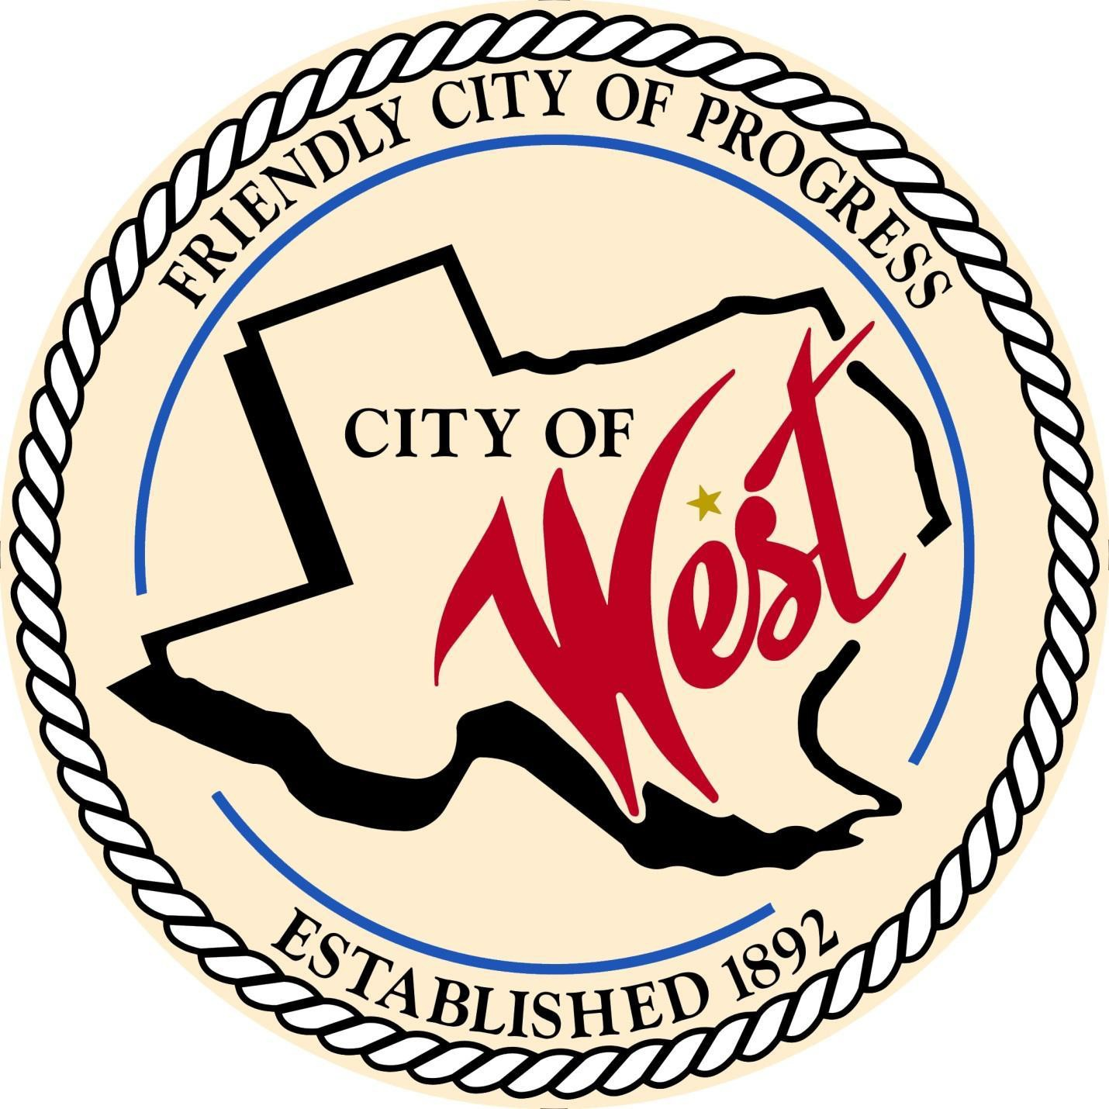

City Council Meeting November 05, 2024

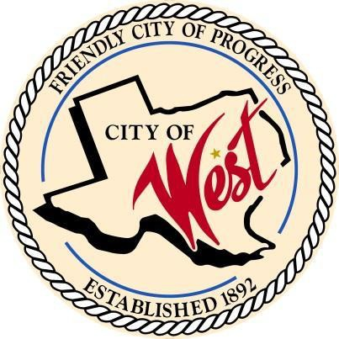City of West

110 N. Reagan, West, Texas 76691

Phone (254) 826-5351 Fax (254) 826-5969

THE WEST CITY COUNCIL WILL MEET ON TUESDAY, NOVEMBER 05, 2024, AT 5:30 PM IN WORKSHOP AT THE WEST VOLUNTEER FIRE DEPARTMENT, 111 S. REAGAN TO DISCUSS ITEMS ON THE AGENDA. THE REGULAR COUNCIL MEETING WILL START AT 6:00 PM.

1. Call to Order
2. Invocation and Pledge
3. Roll Call
4. Citizen Comments will be heard, but please note that speakers are strictly limited to 3 minutes. It is important to remember that the council will only discuss matters that are listed on an official agenda as required by law, and no discussion will be held on any other topics.
5. Consent Agenda:

The consent agenda includes all matters considered to be of a routine or noncontroversial nature. All items on the consent agenda are approved by a single motion and vote. Any item on the consent agenda can be removed at the request of any member of the Council or City staff. Any items removed are considered separately by the City Council after the consent agenda.

* 1. Approve Minutes: October 01, 2024
  2. Approve Bills: October 2024
  3. Monthly Departmental Reports:
     + Police Department Report
     + Public Works Report
     + Fire Marshal Report
     + Code/Permitting Report
     + Engineer Report
     + Mayor Report
     + Project expenditure report
     + Sales tax allocation/ EDC report

1. Discussion, consideration, action, if any, re: West Hospital Authority to have the following names considered for placement on their Board of Directors: City Place 2 Rebecca Kolar, City Place 4 Mike Sulak – Randy Niemeyer
2. Discussion, consideration, action, if any, re: Grant proposal under the MVCPA catalytic converter grant, FY 2025 – Chris White
3. Discussion, consideration, action, if any, re: Hotel tax budget and request – David Pratka
4. Discussion, consideration, action, if any, re: Rezoning the property at 209 N. Harrison to commercial – West ISD, David Truitt/ Mike Sulak
5. Discussion, consideration, action, if any, re: Replating the property located at 506-510 W. Broadway – Freddy Polansky / Mike Sulak
6. Discussion, consideration, action, if any, re: Replating the property located at 600 W. Broadway – Freddy Polansky / Mike Sulak
7. Discussion, consideration, action, if any, re: Ballot selection for Board of Directors of the McLennan Central Appraisal District – David Pratka
8. Council member comments and requests for items to be placed on future agendas.
9. Adjourn

CERTIFICATION

I certify that the above notice of the meeting was posted on the bulletin board of the West City Hall in the City of West, Texas on the

1st day of November 2024 at 9:00 a.m.

City Secretary Robin Wylie